**<<TITLE >>**

**INLAB INTERNSHIP REPORT**

***Submitted by***

**VIVEGAN CJ (21C017)**

**BACHELOR OF ENGINEERING/TECHNOLOGY**

***in***

**COMPUTER SCIENCE ENGINEERING**

**THIAGARAJAR COLLEGE OF ENGINEERING, MADURAI – 625 015**

**October 1–15 , 2023**



**THIAGARAJAR COLLEGE OF ENGINEERING(TCE), MADURAI- 625 015**



**BONAFIDE CERTIFICATE**

Certified that this Virtual Internship report <<title>>is the bonafide work of _________________Department of COMPUTER SCIENCE ENGINEERING who carried out the InLab Internship at TCE between

October 1–15 , 2023.

Submitted for Evaluation held at Thiagarajar College of Engineering on October 15 , 2023.

|  |  |  |
| --- | --- | --- |
| **EXAMINER 1** |  | **EXAMINER 2** |
| **(Name with Signature)** |  | **(Name with Signature)** |

**Abstract**

This internship report encapsulates a four-week immersive experience at Ozis Technologies, focused on the dynamic intersection of web development and UI/UX design. The primary objective was to gain practical insights into the field, emphasizing the creation of user-centric interfaces and translating them into a functional website. The technology stack employed Figma for UI/UX design and HTML for website development.

The report delves into the collaborative process of UI/UX design using Figma, encompassing wireframes, high-fidelity mock-ups, and interactive prototypes. The subsequent implementation phase involved translating the finalized designs into a live website using HTML. Special emphasis was placed on responsive design principles to ensure a consistent user experience across diverse devices.

The report highlights the meticulous alignment of HTML implementation with Figma design specifications, ensuring visual consistency throughout the website. Cross-browser compatibility emerged as a key consideration, with rigorous testing undertaken to guarantee a reliable performance across popular web browsers.

The outcomes of the internship include successful translation of UI/UX designs from Figma to a live website, showcasing the effectiveness of the conceptualization phase and the seamless transition from design to development. The report concludes with insights into the impact of the internship experience on enhancing skills in web development, UI/UX design, and the practical application of theoretical knowledge in a professional setting.

**Table of Contents**

**Chapter No Title Page_No**

**Bonafide Certificate**

**Abstract**

1. **Introduction**
2. **Background**
3. **Objectives**
4. **Purpose of the work**
5. **Problem Formulation**
6. **Conceptual Design**
7. **Results and Discussion**
8. **Conclusion and Future Enhancements**
9. **References**

**INTRODUCTION**

During my four-week internship at Ozis Technologies, which commenced on December 7th and concluded on January 6th, I had the privilege of immersing myself in the dynamic field of web development. This immersive experience was exclusively focused on frontend development, allowing me to actively contribute to the creation of a website.

Ozis Technologies, recognized as a forward-thinking organization with a strong commitment to technological innovation, provided a stimulating environment. Within this innovative setting, I had the opportunity to enhance my skills and gain hands-on experience in the ever-evolving landscape of web development.

In my role as a frontend developer within the Ozis Technologies team, my primary responsibility was to shape the visual and interactive elements of the website, ensuring an optimal user experience. This internship served as a valuable platform for me to apply theoretical knowledge in a real-world setting, significantly deepening my understanding of frontend technologies.

Notably, my involvement extended beyond traditional frontend development, as I actively collaborated with the UI/UX team during the initial stages of designing the website. This collaborative effort broadened my perspective on user interface and experience design, adding an enriching layer to my overall internship experience.

In this introductory section, we will delve into the organizational context, explore my specific role, and discuss the brief yet impactful duration of this immersive internship. Additionally, we'll highlight the significance of web development within the realm of Ozis Technologies and its broader implications in the industry. Through this report, my aim is to provide insights into the transformative experiences and substantial contributions made during my tenure as a frontend developer at Ozis Technologies.

**BACKGROUND:**

Ozis Technologies, the backdrop for my four-week internship, is a cutting-edge tech organization known for its forward-thinking approach and commitment to technological innovation. Situated at the forefront of the industry, Ozis Technologies has established itself as a key player in delivering sophisticated solutions in web development.

**Project Context:**

The specific project I contributed to during my internship involved the creation of a website, aligning with Ozis Technologies' broader mission to leverage technology for meaningful impact. This venture encapsulated the essence of user-centric design, where UI/UX principles played a pivotal role.

**UI/UX Collaboration:**

In the initial stages of the project, I actively collaborated with the UI/UX team to craft a comprehensive overview of the website's design. This collaborative effort allowed for a holistic understanding of the user's journey, emphasizing the importance of aesthetics, functionality, and user satisfaction.

**Development Initiation:**

With the UI/UX foundation in place, the transition to development marked the initiation of coding in HTML and CSS. This phase aimed to transform the envisioned design into a tangible, interactive website. The seamless integration of design principles and coding practices became imperative for a cohesive and user-friendly end product.

**Industry Landscape:**

The industry context surrounding Ozis Technologies is dynamic and competitive, characterized by rapid technological advancements. Ozis Technologies, in line with industry trends, stands as a beacon of innovation, offering solutions that transcend conventional boundaries.

In this section, we have set the stage by providing insights into Ozis Technologies' innovative standing, the overarching project goals, and the initial collaboration with the UI/UX team. As we progress through this report, we will delve into the intricacies of the development process, highlighting the synergy between design and coding in the creation of a compelling website.

**OBJECTIVE**:

**Learning Objectives:**

**Mastery of Frontend Technologies:**

Develop a comprehensive understanding of frontend technologies, focusing on HTML, CSS, and their effective integration.

**Hands-On Experience in UI/UX Collaboration:**

Gain practical experience by actively participating in the UI/UX design process, fostering a holistic approach to website development.

**Application of Theoretical Knowledge:**

Apply theoretical knowledge acquired during academic studies in a real-world setting, emphasizing practical problem-solving and industry best practices.

**Project Contributions:**

Active Involvement in Website Creation:

Actively contribute to the creation of a website from conception to implementation, aligning with UI/UX design principles.

**Coding Proficiency:**

Enhance coding proficiency in HTML and CSS, with a focus on writing clean, efficient code that translates design concepts into functional and visually appealing web pages.

**User-Centric Design Implementation**:

Implement user-centric design principles to ensure an optimal user experience, emphasizing accessibility, responsiveness, and intuitive navigation.

**Reflection and Self-Improvement:**

Engage in reflective practices to assess personal growth, identifying areas of strength and areas for continuous improvement in both technical and soft skills.

### PURPOSE OF WORK:

During my internship at Ozis Technologies, I underwent a transformative journey that significantly contributed to both my personal and professional growth within the expansive realm of web development. The overarching purpose of this experience, from my perspective, can be delineated into several key facets.

Firstly, the internship served as an invaluable platform for skill enhancement, providing me with hands-on experience in frontend development. I dedicated my efforts to refining my proficiency in essential technologies such as HTML, CSS, and delving into the intricate principles of UI/UX design. This immersive experience not only deepened my technical capabilities but also allowed me to witness the practical application of these skills in a professional setting.

Furthermore, the internship facilitated the real-world application of the theoretical knowledge acquired in academic settings. This emphasis on bridging the gap between educational insights and practical implementation was instrumental in fostering a more comprehensive understanding of how web development principles function within the dynamics of a real-world scenario.

Exposure to the professional dynamics of a tech-oriented workplace constituted another crucial aspect of my internship. This exposure not only provided me with insights into industry practices but also nurtured qualities of adaptability, collaboration, and effective communication within a team setting. Being immersed in a professional environment allowed me to understand the nuances of working in a collaborative and fast-paced tech-oriented setting.

A significant component of my role was actively contributing to the advancement of a key organizational initiative, involving the accelerated development of a website project. By participating in frontend development, I witnessed firsthand the impact of my contributions on the realization of this organizational goal. This experience not only sharpened my technical skills but also instilled a sense of accomplishment in actively contributing to a tangible project.

The internship underscored the importance of interdisciplinary collaboration by fostering a cohesive approach between frontend development and UI/UX design teams. This collaborative synergy ensured the seamless integration of design principles into the coding process, resulting in a holistic and user-centric development methodology.

Beyond individual skill enhancement, my role extended to skill diversification, aiming to bolster the overall competence of the organization. By infusing fresh perspectives and insights gained through collaboration, I actively contributed to enhancing the collective skill set of the team, thereby adding value to the organization.

**PROBLEM FORMULATION**:

In the dynamic intersection of UI/UX design and HTML/CSS development, meticulous attention was dedicated to successfully navigating several challenges. The pursuit of achieving and maintaining visual consistency across diverse UI elements demanded a keen eye for detail, specifically in color schemes, typography, and overall aesthetics. Designing an intuitive and user-friendly navigation structure posed a significant challenge, requiring a delicate balance between visual appeal and ease of navigation. This equilibrium was achieved through thoughtful consideration and rigorous testing.

Translating the intricate UI/UX design into HTML and CSS code presented challenges in maintaining fidelity while addressing technical constraints. The pivotal role of close collaboration between design and development teams became evident in overcoming these hurdles. Integrating feedback from both UI/UX designers and developers demanded a delicate balance, ensuring the seamless incorporation of design revisions into the HTML/CSS codebase. Effective communication and a collaborative mindset played instrumental roles in this intricate process.

The implementation of responsive design, crucial for cross-device compatibility, brought forth challenges across various devices, including desktops, tablets, and mobile devices. Thorough testing and adaptation were crucial to ensuring an optimal user experience across different screen sizes. The delicate act of balancing visual richness with website performance created a dilemma, necessitating strategic decision-making. Paramount to maintaining equilibrium between aesthetics and load times was the optimization of images and code.

In the face of these challenges, the intersection of UI/UX design and HTML/CSS development emerged as a dynamic space for creativity, collaboration, and problem-solving. The successful navigation of this interdisciplinary process was realized through a combination of strategic design choices and effective collaboration practices, highlighting the resilience and innovation within this symbiotic relationship.

**CONCEPTUAL DESIGN:**

**Initial Planning:**

**Scope Definition:**

The conceptual design phase commenced with a comprehensive definition of the project scope. Discussions with stakeholders and a thorough understanding of the organization's goals set the parameters for design exploration.

**Figma for UI/UX Design**:

UI/UX design was executed in Figma, leveraging its collaborative features. The initial plans included creating wireframes and high-fidelity mock-ups to visualize the user interface and experience.

**Wireframing and Mock-Ups:**

**Wireframes in Figma:**

Low-fidelity wireframes were crafted to establish the basic structure and layout of the website. These wireframes served as a skeletal representation, focusing on the placement of key elements and overall content organization.

**High-Fidelity Mock-Ups:**

Transitioning from wireframes, high-fidelity mock-ups were developed in Figma. These detailed representations incorporated color schemes, typography, and visual elements, offering a realistic preview of the final website appearance.

**Design Principles and Methodologies:**

**User-Centered Design (UCD):**

Adherence to User-Centered Design principles was integral. Iterative testing and feedback loops in Figma ensured that design decisions were aligned with user needs and preferences.

**Responsive Design in Figma:**

Figma facilitated the consideration of responsive design principles from the outset. Design elements were optimized for various screen sizes, ensuring a consistent and user-friendly experience across devices.

**Prototyping and Feedback:**

**Interactive Prototypes in Figma:**

Interactive prototypes were created in Figma to simulate user interactions. This allowed for a dynamic evaluation of the design's functionality and flow, helping identify potential user experience improvements

**RESULTS AND DISCUSSIONS:**

The technology stack employed for the project showcased a seamless integration of design and development tools, with Figma playing a pivotal role in the UI/UX design phase and HTML/CSS driving the website development. The collaborative nature of the UI/UX design process in Figma facilitated the creation of comprehensive wireframes, high-fidelity mock-ups, and interactive prototypes. This collaborative environment allowed the team to iteratively refine the design, ensuring that it met both aesthetic and functional requirements.

The subsequent website development phase leveraged HTML and CSS to translate the finalized design into a fully functional and visually appealing website. An emphasis was placed on incorporating responsive design principles, a noteworthy aspect that ensured the website provided a consistent and user-friendly experience across a diverse range of devices and screen sizes. The inclusion of interactive components, as envisioned in Figma prototypes, further enriched the user experience by enhancing engagement through elements like buttons and sliders.

A meticulous approach was taken during the development process to align the HTML and CSS implementation with the design specifications outlined in Figma. This commitment to precision resulted in visual consistency throughout the website, effectively translating the conceptualized design into a tangible digital experience.

Cross-browser compatibility emerged as a key consideration, and the team conducted rigorous testing to ensure that the website performed reliably across various popular web browsers. This dedication to compatibility was pivotal in delivering a seamless and consistent user experience, catering to a diverse audience.

One of the project's standout outcomes was the successful translation of UI/UX designs from Figma to a live website. This accomplishment underscored the effectiveness of the conceptualization phase, demonstrating a smooth transition from design to development. The final product not only met but closely mirrored the envisioned design, showcasing a well-executed and visually appealing website that effectively met the project's goals and user expectations. Overall, the project highlighted the efficacy of a well-integrated and collaborative approach to UI/UX design and web development, resulting in a successful and impactful digital product..

**UI/UX DESIGN: (T00L: FIGMA)**

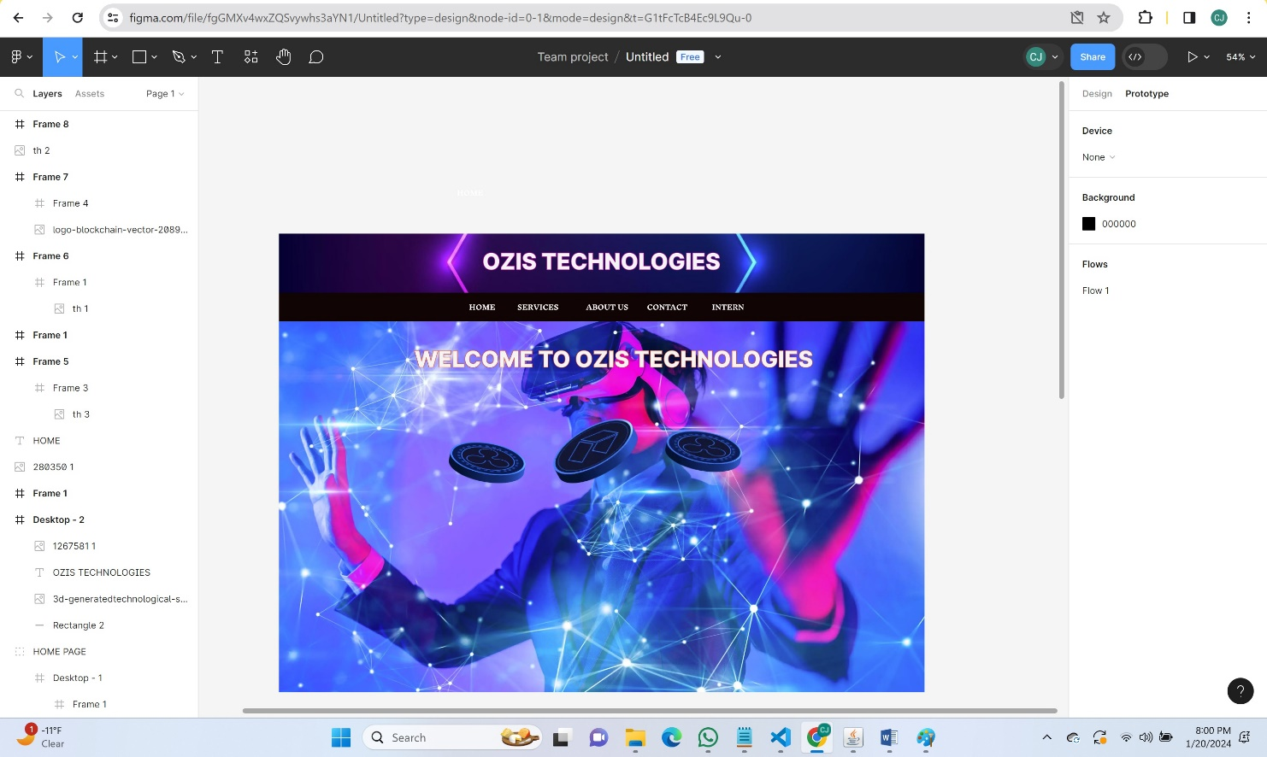

**PAGE 2:** 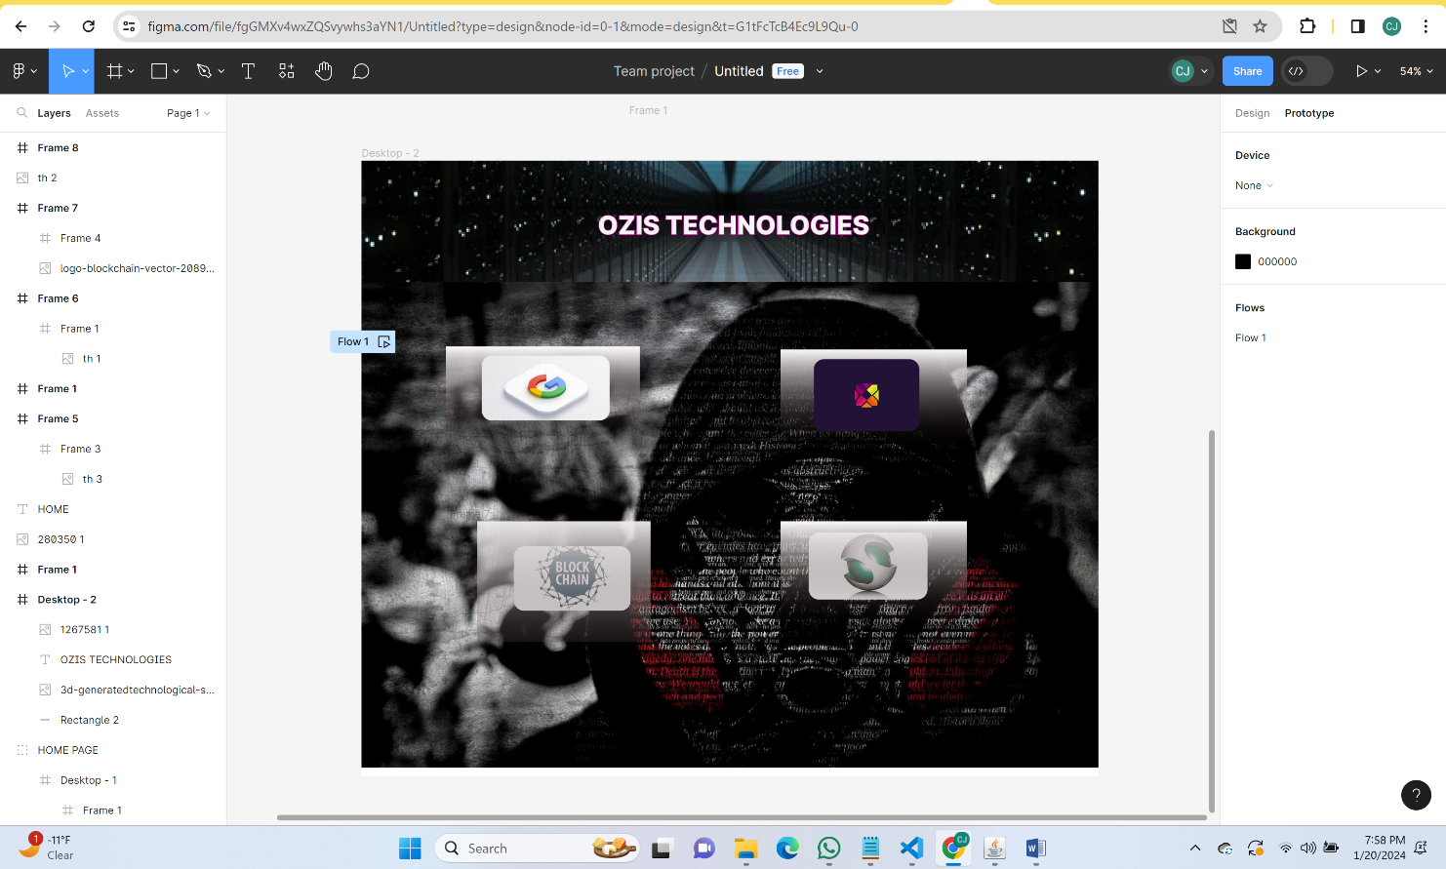

**PAGE 3:**

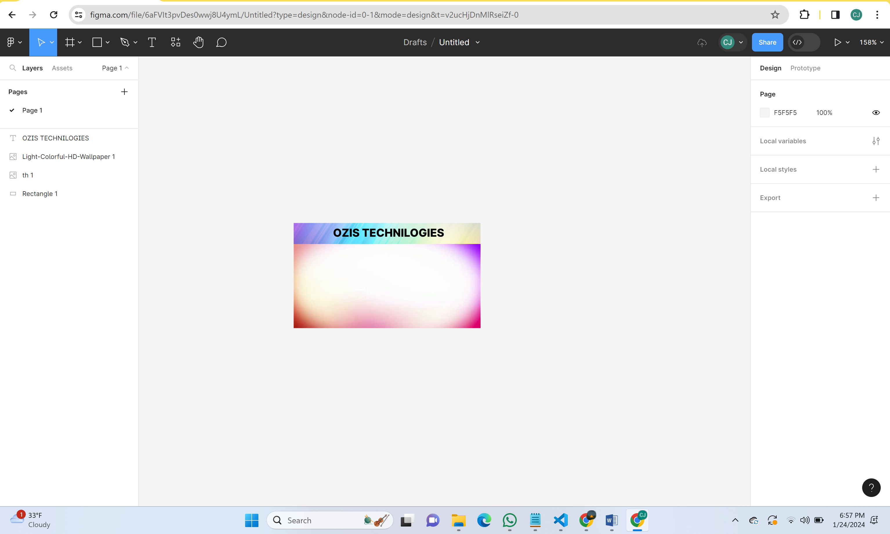

**HTML/CSS DESIGN:[VS CODE]**

**HOME PAGE:**

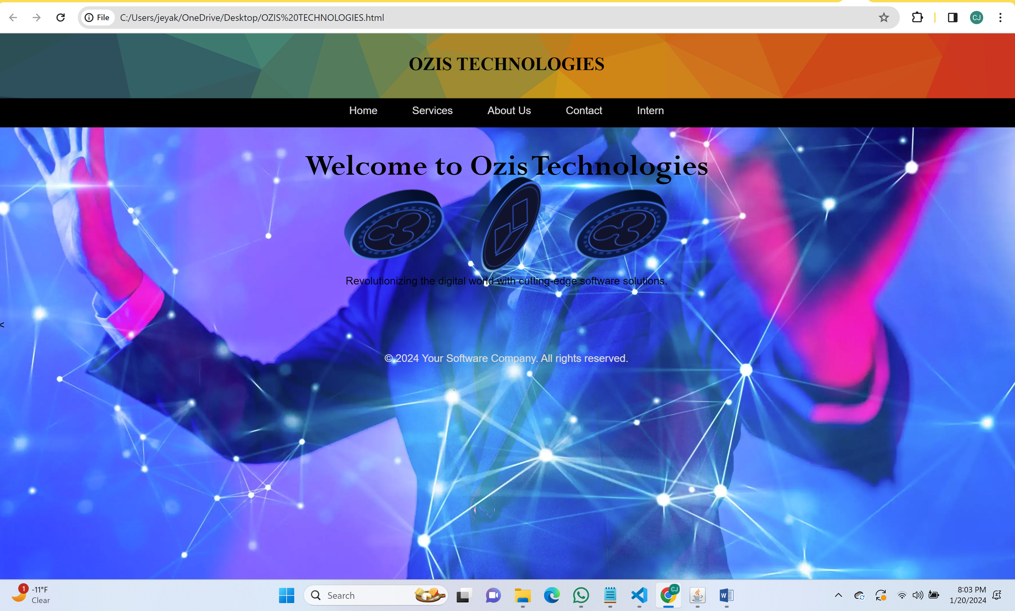

**SERVICES PAGE:** 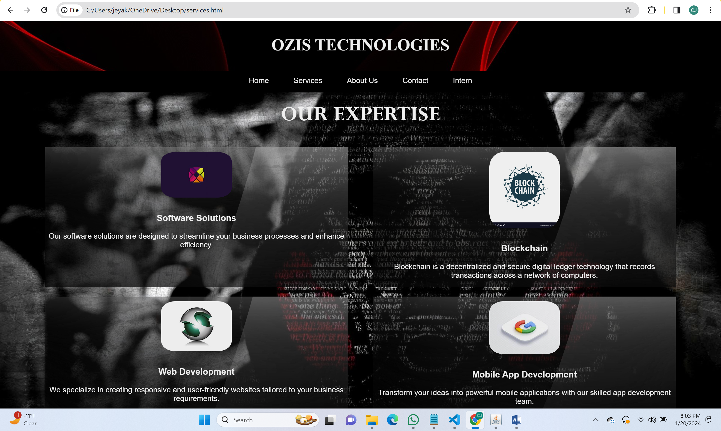

**ABOUT US PAGE:**

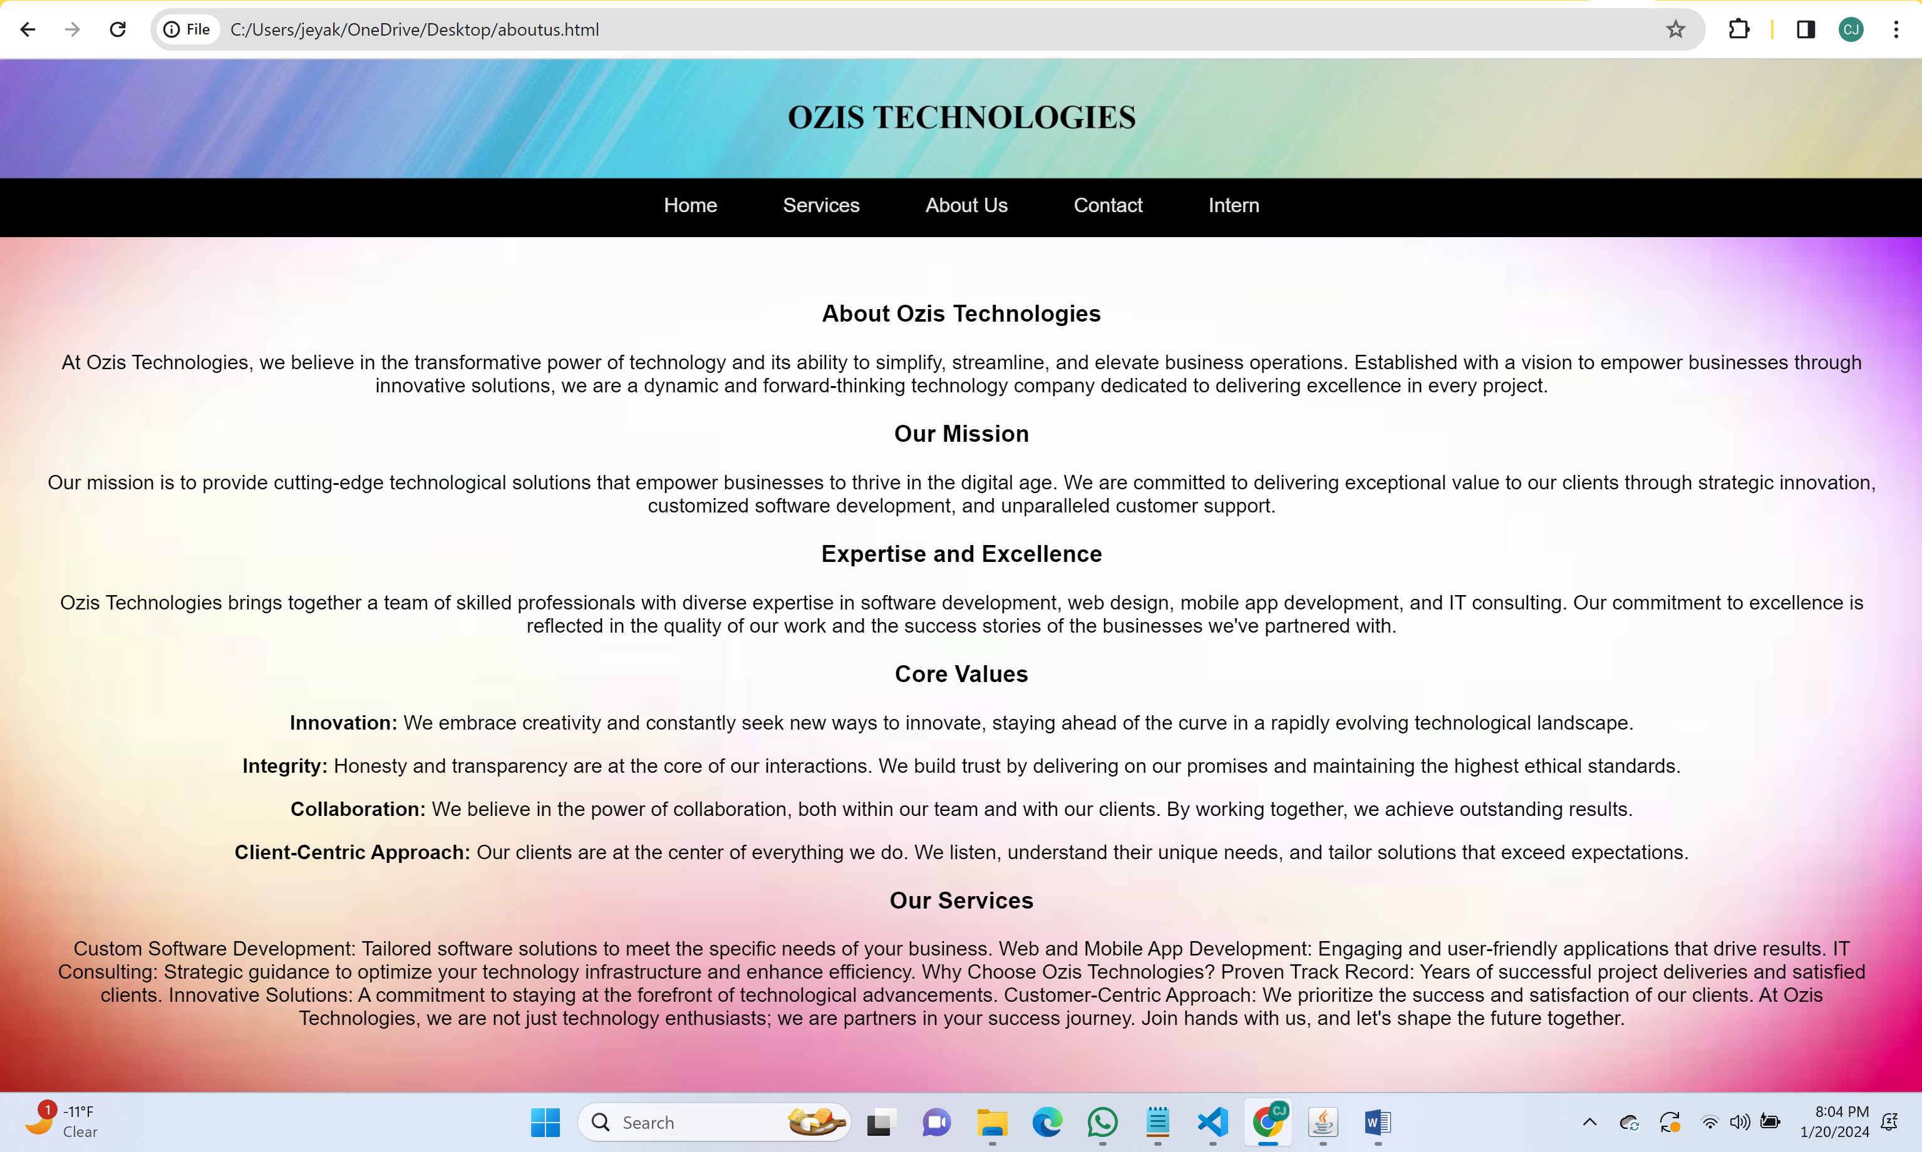

**CONTACT:**

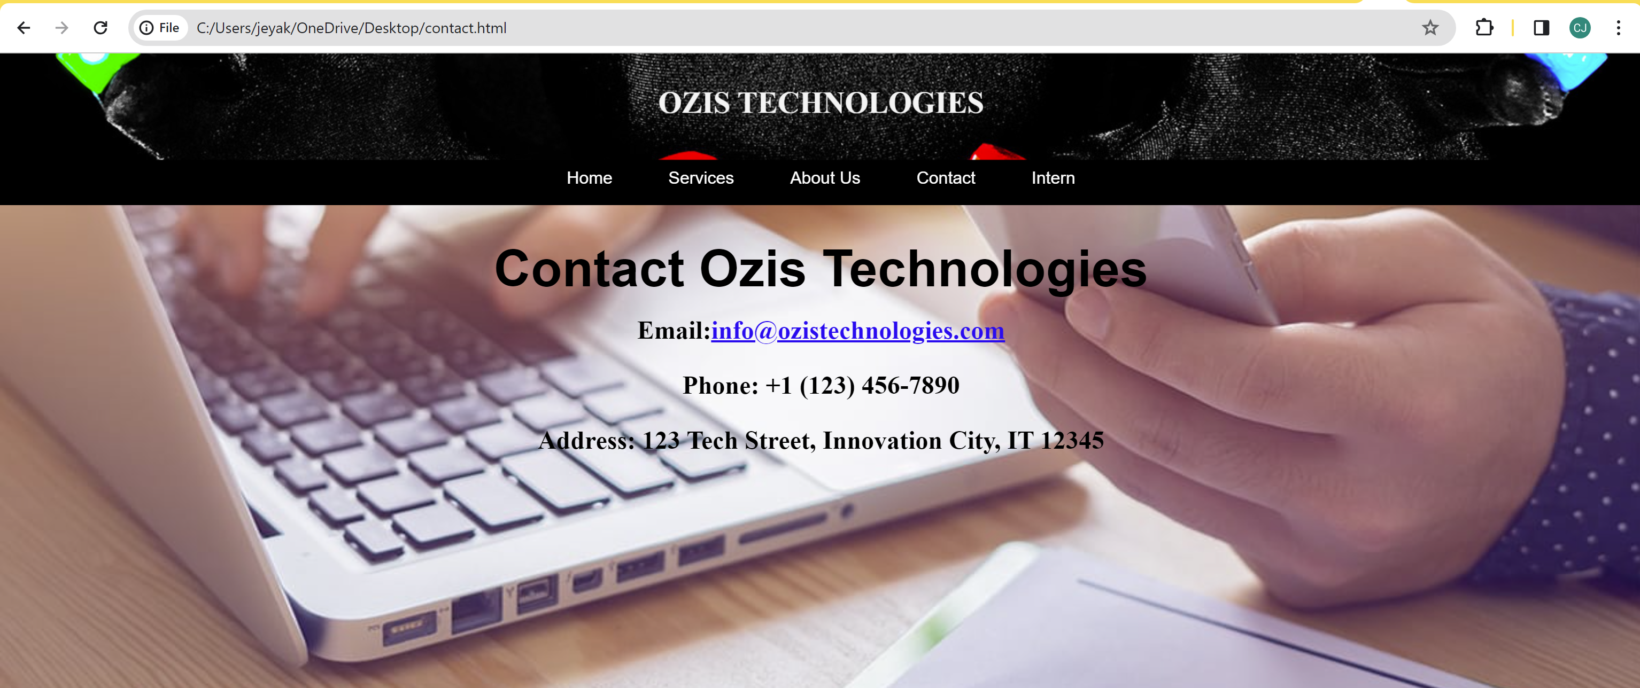

**INTERN PAGE:**

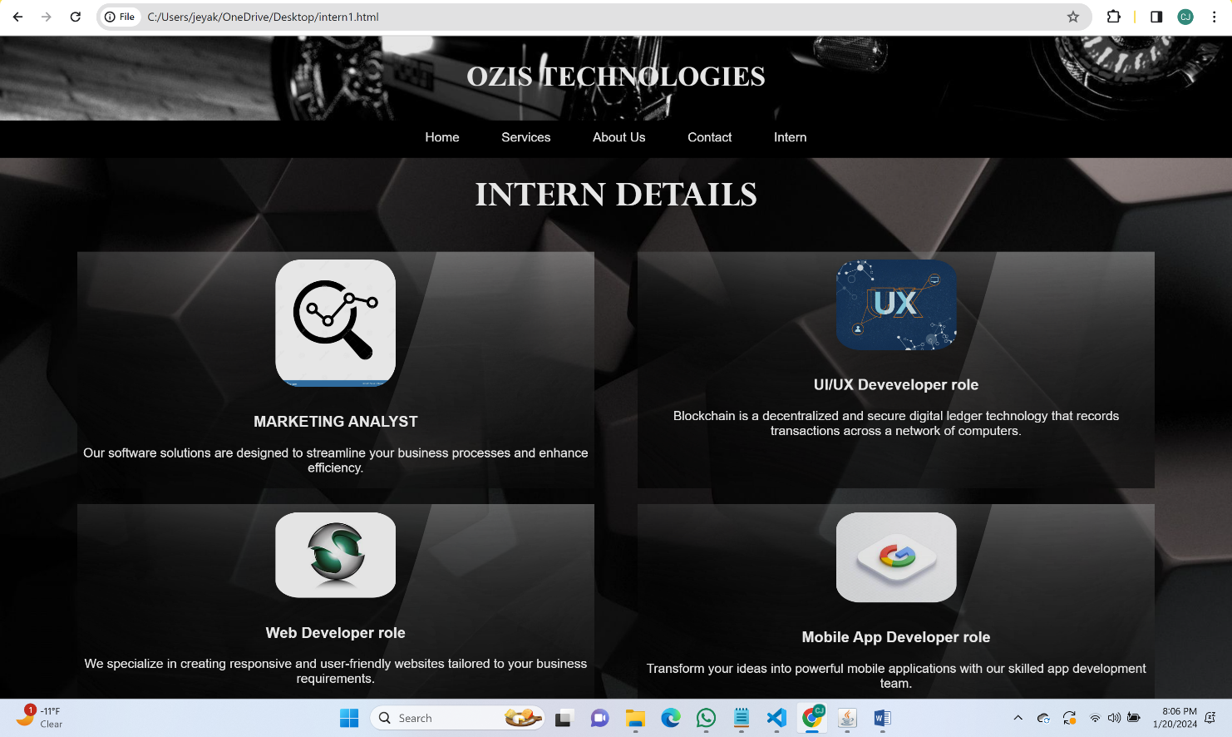

**CONCLUSION AND FUTURE REQUIREMENTS:**

The internship at Ozis Technologies has been an enriching journey, offering a comprehensive learning experience and honing skills in both UI/UX design and frontend development using Figma, HTML, and CSS.

Effective collaboration emerged as a cornerstone of success, emphasizing the significance of clear communication and interdisciplinary teamwork. The dynamic nature of web development presented opportunities for adaptability and problem-solving, highlighting the practical application of theoretical knowledge in a real-world setting.

Areas of excellence included the seamless transition from UI/UX designs to a live website, showcasing meticulous attention to detail and a deep understanding of the design-to-development processes. The implementation of a responsive design approach further demonstrated the ability to create visually appealing and user-friendly websites across various devices.

Identified areas for improvement include refining time management strategies, especially in the context of a condensed internship period, and delving deeper into advanced technologies and frameworks to enhance technical expertise.

Looking ahead, future enhancements encompass the integration of dynamic content and interactive elements using JavaScript, incorporation of backend technologies for advanced features, and the establishment of a user feedback mechanism for iterative refinement. Exploring additional design tools beyond Figma is also envisioned to broaden the skill set.

In conclusion, the internship at Ozis Technologies laid a strong foundation for future endeavors in web development. The commitment to continuous learning and improvement ensures a sustained trajectory of growth in this dynamic field. The valuable experiences gained will undoubtedly contribute to success in the multifaceted world of web development.

**REFERENCES:**

**UI/UX Design:**

**Figma Documentation:**

Figma Documentation provided comprehensive guidance on using Figma for UI/UX design, including features, collaboration tools, and best practices.

**UI/UX Design Principles:**

The book "Don't Make Me Think" by Steve Krug served as a foundational reference for understanding user-centric design principles and usability.

**Frontend Development:**

**HTML and CSS MDN Web Docs:**

The Mozilla Developer Network (MDN) Web Docs for HTML and CSS offered in-depth documentation and tutorials for frontend development.

**W3Schools:**

W3Schools provided practical examples, tutorials, and references for HTML, CSS, and responsive design techniques.

**Collaboration Tools:**

**Version Control with Git:**

The Pro Git book, available online at Pro Git Book, served as a valuable resource for understanding and implementing version control with Git.

**Communication and Project Management:**

Tools like Slack and Trello were used for effective communication and project management within the team.

**Web Development Communities**:

Engaging with communities like Stack Overflow and Dev.to facilitated discussions, problem-solving, and knowledge sharing with the broader web development community.

**Tech Blogs and Publications:**

Regularly following tech blogs and publications, including Smashing Magazine and CSS-Tricks, provided insights into the latest trends and best practices in web development.